SQA Assignment 1
Fahad Siddiqui
231471220

Test Case 1 and 5:
In test case 1 and 5, I’ve used the technique of doc-test testing. Test case 1 is a program which finds the length of a string and task 5 sums two numbers. If we run these tasks and there are no errors, there will be no output in this method. However we can refer to cmd.exe for further details.
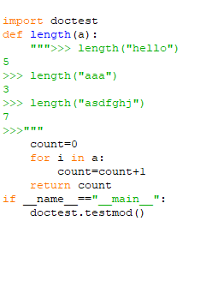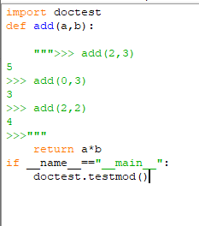
Output without errors:
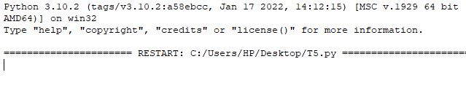
Output with errors in task 1:
Lets say there is an error in the code, for instance there is ‘ - ’ instead of a ‘ + ’,
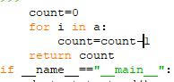
Output would be as follows:
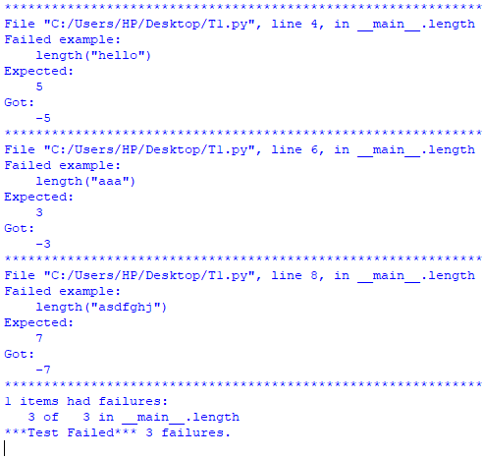
Output with errors for task 5:
Lets say there is ‘ * ’ instead of ‘ + ‘ in our code
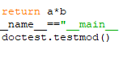
Output would be as follows:

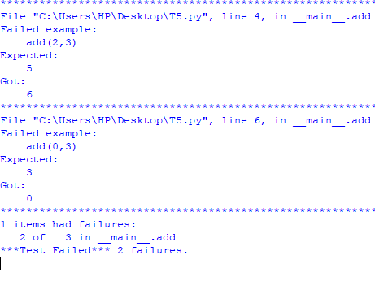

Test case 3 and 4:
In test case 3 and 4 name attribute testing, here it is quite simple to detect errors, you yourself make some conditions if the program falls over them it is a PASS else it is a fail.
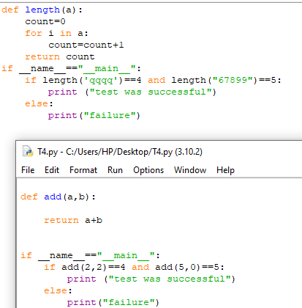
Output for task 3 and 4:
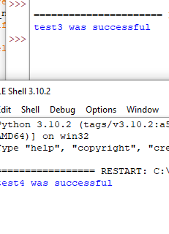
both were successful.

Test Case 2:
in test case 2 I have used unit testing technique, this is also an automated technique for software testing. Here if the software is successful ‘ ok ’ is printed else there is a ‘ F ’ for failure.
NO error case:
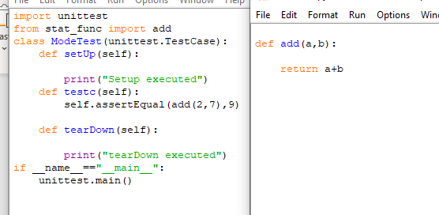
Output:
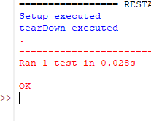
If error:
Output:
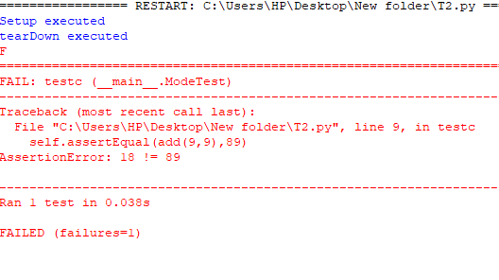
TEST SUITE:

import doctest
def length(a):
""">>> length("hello")
5
>>> length("aaa")
3
>>> length("asdfghj")
7
>>>"""
count=0
for i in a:
count=count+1
return count
if __name__=="__main__":
doctest.testmod()

def add(a,b):
return a+b
import unittest
from stat_func import add
class ModeTest(unittest.TestCase):
def setUp(self):

print("Setup executed")
def testc(self):

self.assertEqual(add(9,9),18)
def tearDown(self):

print("tearDown executed")
if __name__=="__main__":
unittest.main()

def length(a):
count=0
for i in a:
count=count+1
return count
if __name__=="__main__":
if length('qqqq')==4 and length("67899")==5:
print ("test3 was successful")
else:
print("failure")

def add(a,b):
return a+b
if __name__=="__main__":
if add(2,2)==4 and add(5,0)==5:
print ("test4 was successful")
else:
print("tesst4 was failure")

import doctest
def add(a,b):

""">>> add(2,3)
5
>>> add(0,3)
3
>>> add(2,2)
4
>>>"""
return a+b
if __name__=="__main__":
doctest.testmod()

